Project Design Phase-II
Data Flow Diagram & User Stories

Date | 28 February 2026
Team ID | LTVIP2026TMIDS43269
Project Name | Flight Finder: Navigating Your Air Travel Options
Maximum Marks | 4 Marks

Data Flow Diagrams:
A Data Flow Diagram is a traditional visual representation of the information flows within a system. A neat and clear DFD can depict the right amount of the system requirement graphically. It shows how data enters and leaves the system, what changes the information, and where data is stored.
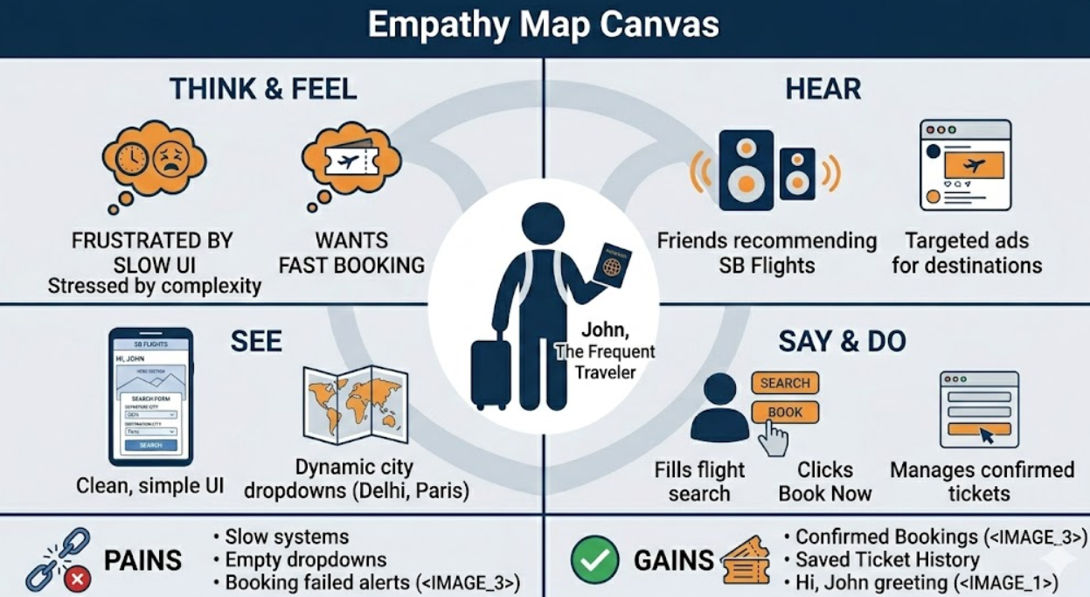
User Stories Table
User Type | Functional Requirement (Epic) | USN | User Story / Task | Acceptance Criteria | Priority | Release
Customer (Web User) | Flight Search | USN-6 | As a user, I can select origin and destination cities from dynamic dropdowns. | Dropdowns populate with unique cities from the database. | High | Sprint-2
Customer (Web User) | Flight Search | USN-7 | As a user, I can view available flights after clicking the search button. | Filtered flight cards appear with price and time details. | High | Sprint-2
Customer (Web User) | Booking | USN-8 | As a user, I can book a flight by clicking the "Book" button. | "Flight Booked Successfully!" alert appears. | High | Sprint-3
Customer (Web User) | Dashboard | USN-9 | As a user, I can view all my confirmed tickets in the "My Bookings" page. | Confirmed tickets are persistently listed with flight names. | High | Sprint-3
Administrator | Data Management | USN-10 | As an admin, I can populate the database with flight data using a seed route. | Visiting /seed clears old data and inserts new flight records. | Medium | Sprint-1

